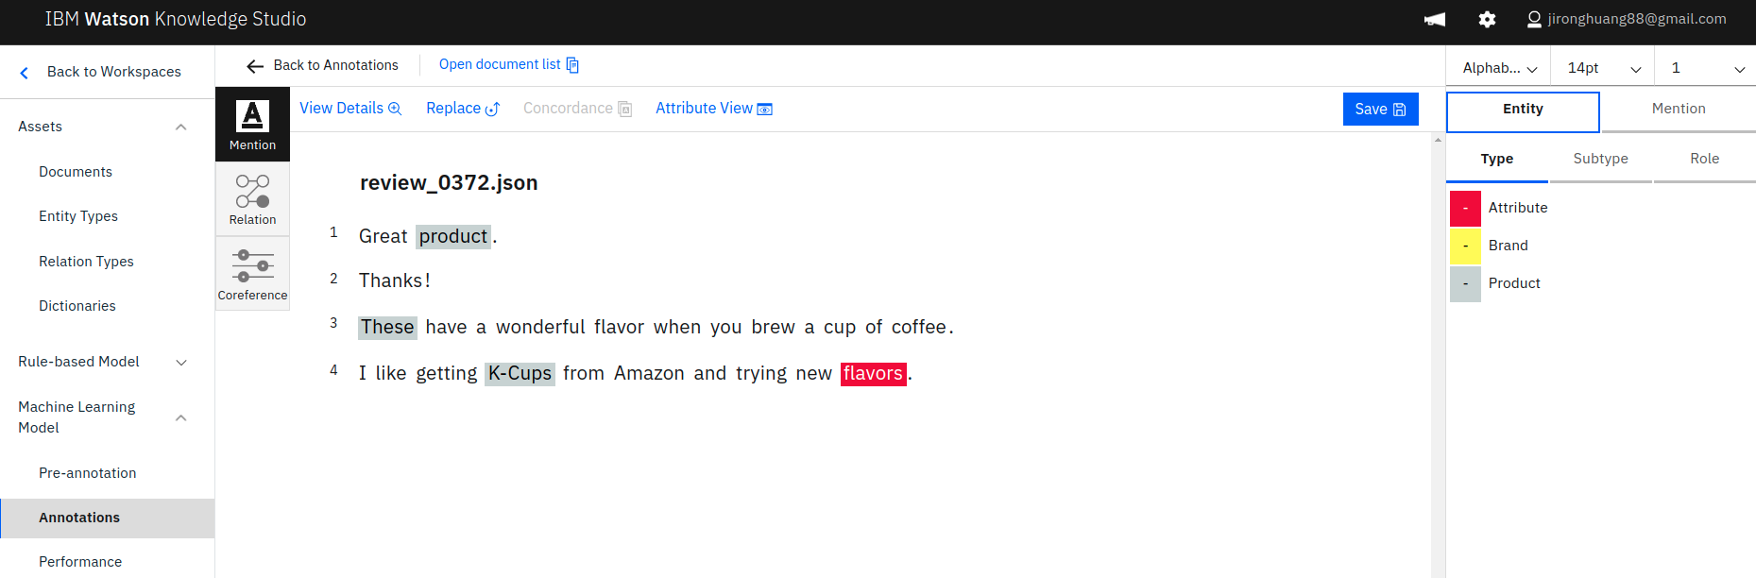

print(json.dumps(response_entity, indent=2))
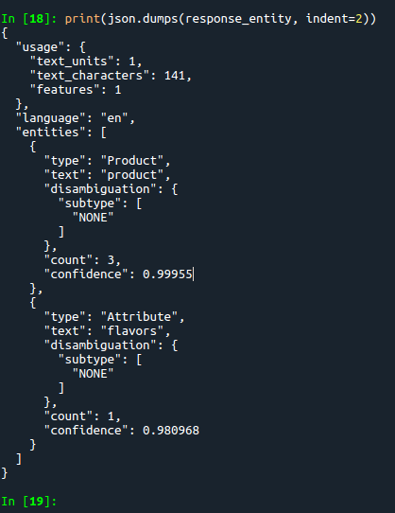

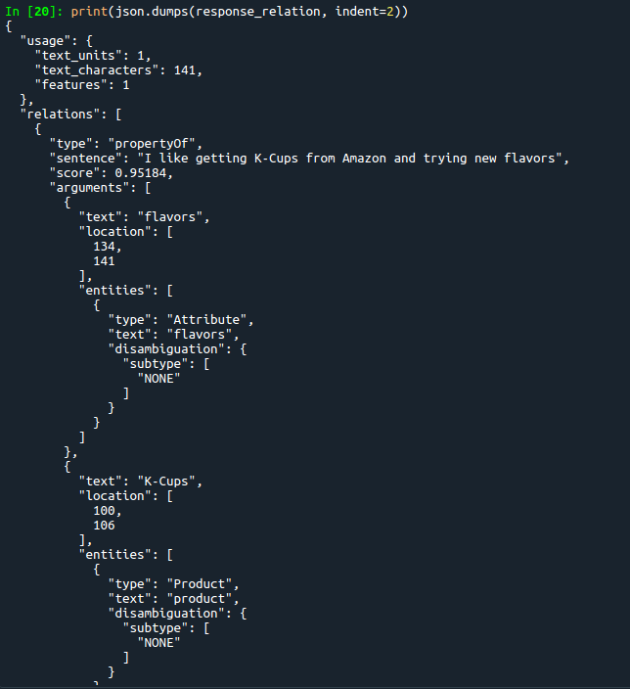
print(json.dumps(response_relation, indent=2))

